Fact sheet

Rosa rugosa |  | Rosa pimpinellifolia  Rosa spinosissima
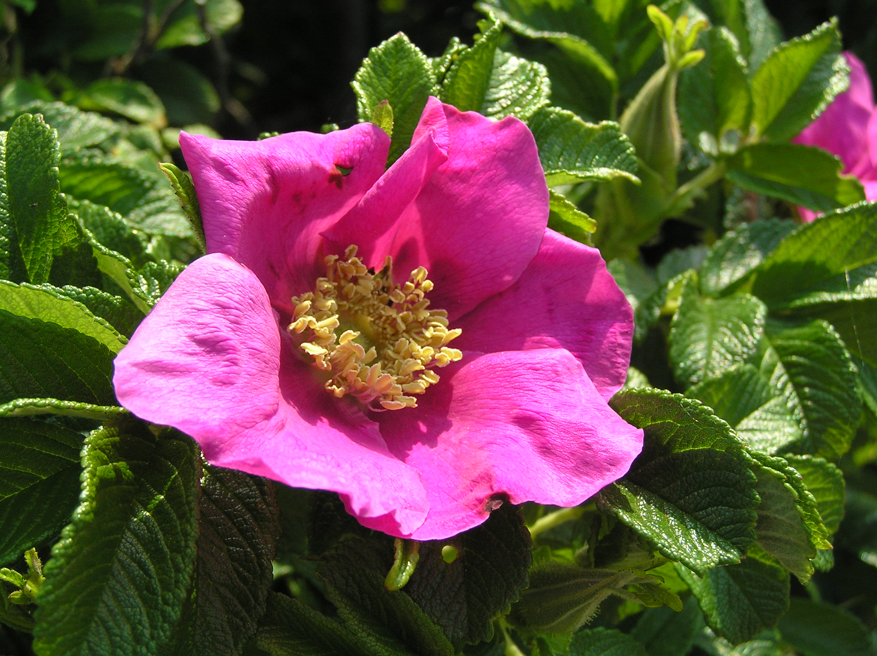  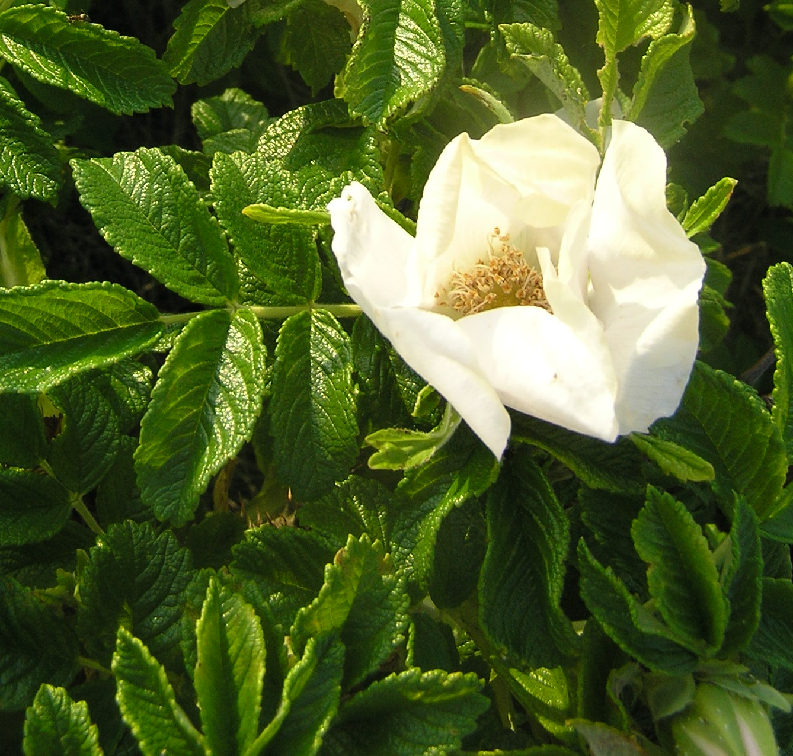 |  | 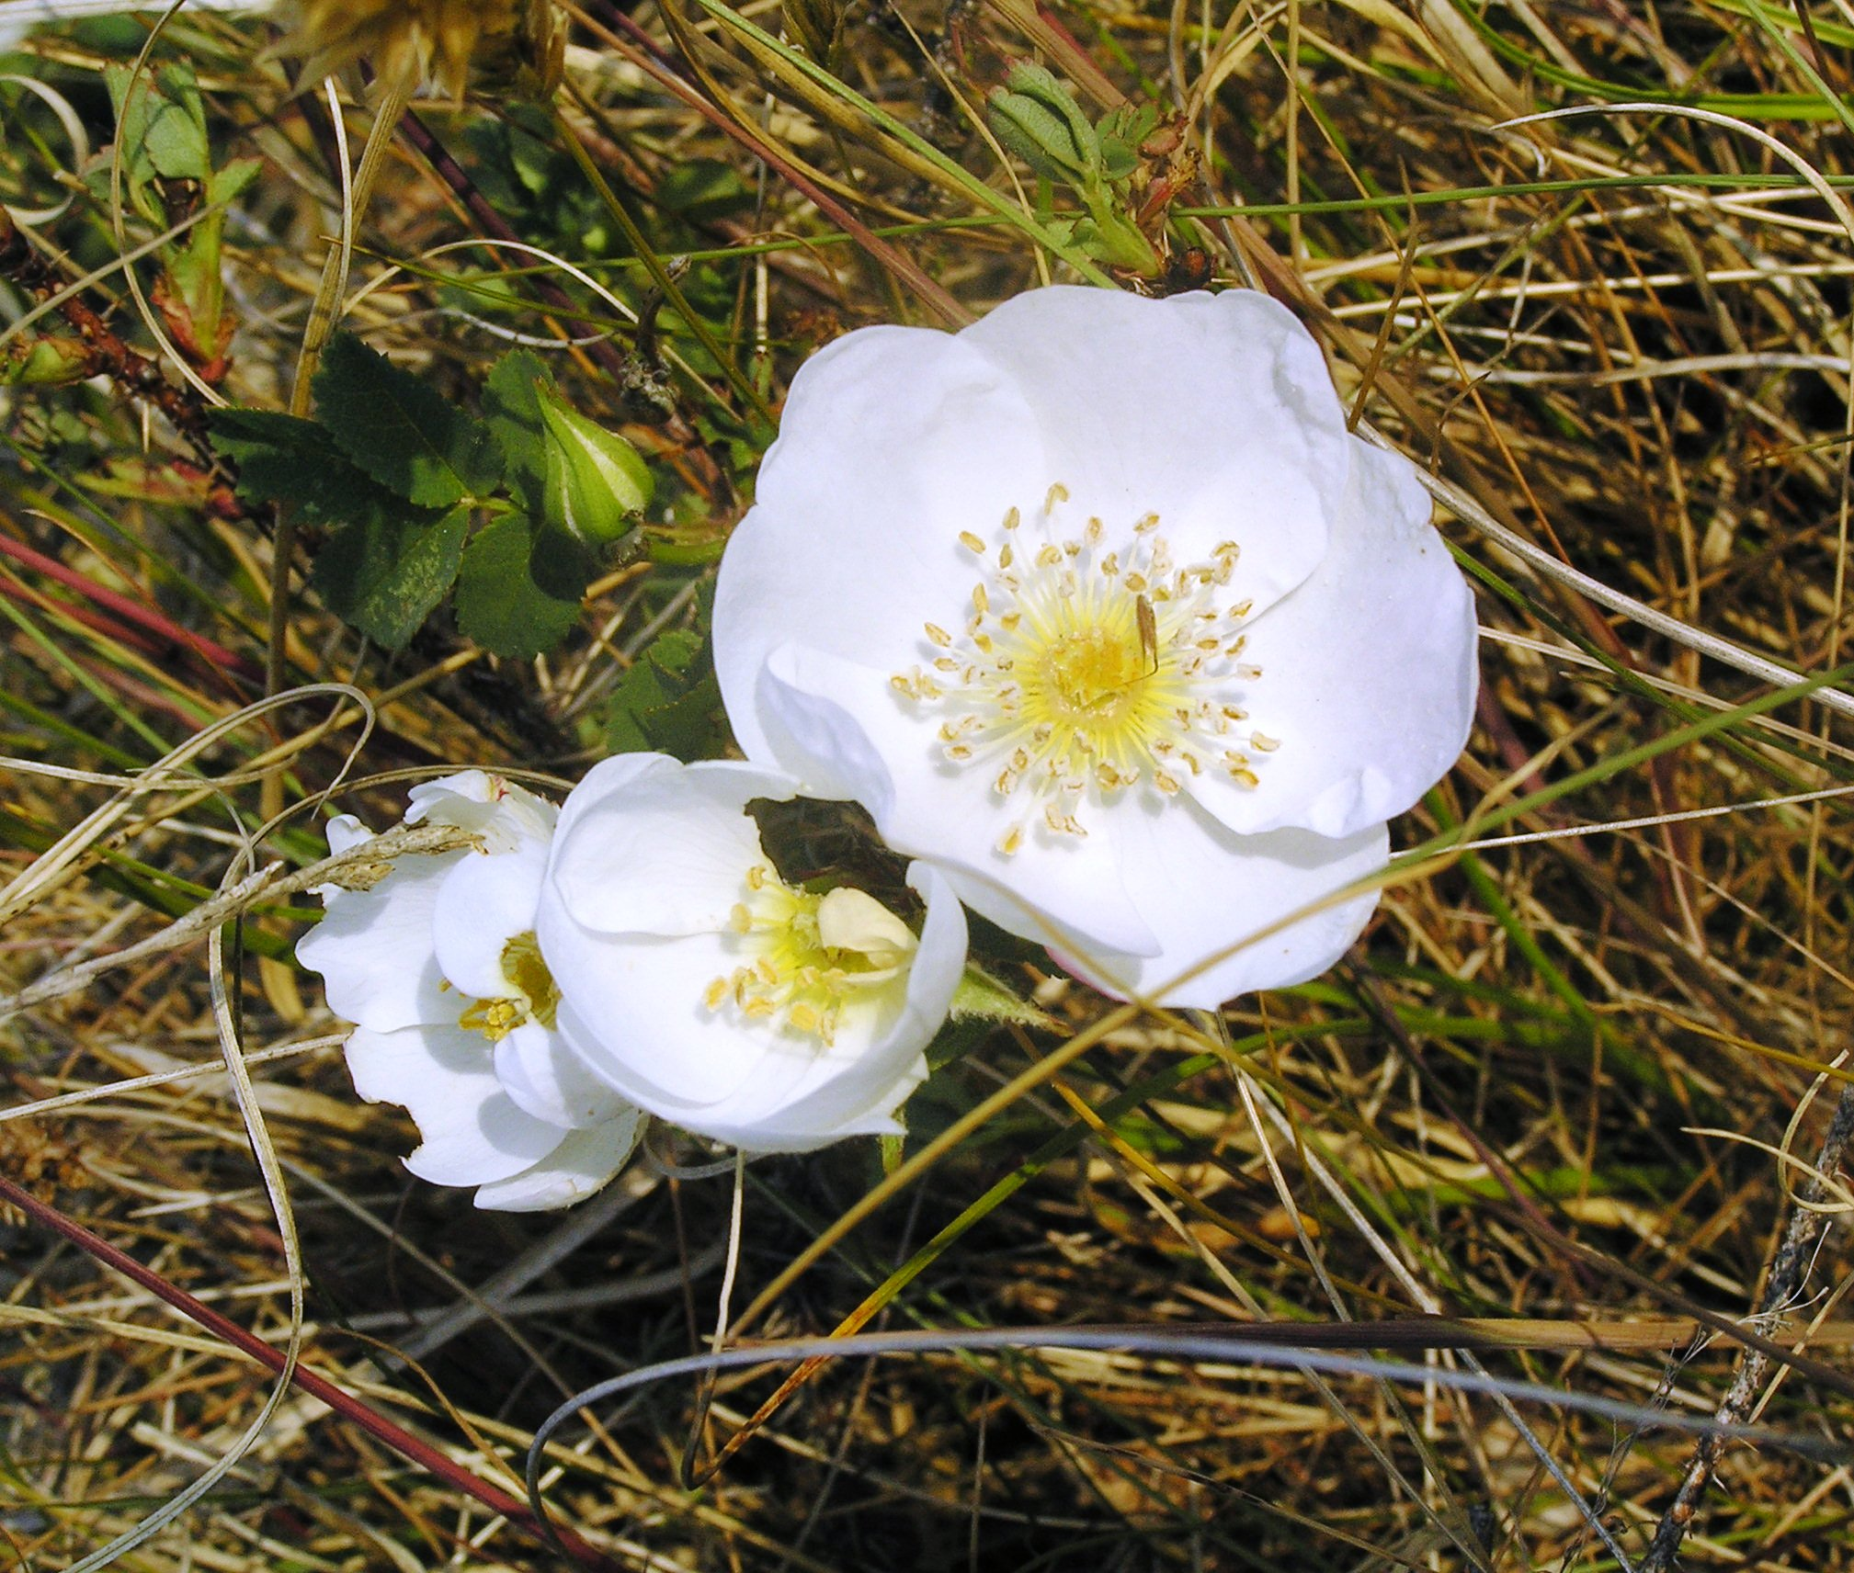  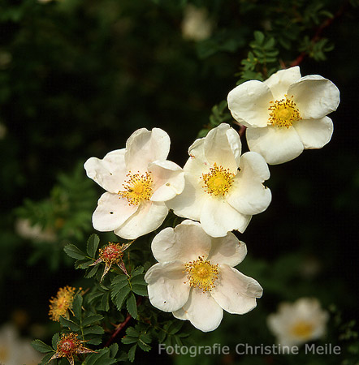
Common names
Japanese Rose, Kamchatka Rose, Kartoffel-Rose, Sylt Rose |  | Dune Rose, Bibernellrose
Origin
Eastern Asia(Korea, Japan, China) |  | native in Western coastal Europe
General characteristics
Height: 0,5-2m  Flowers: 2-8cm across, white or light to dark pink  Fruits: large and slightly flattened, shiny, deep red |  | Height: 10 – 70cm  Flowers: 4 cm, white or light beige  Fruits: till 1,5 cm, globular dark purple to black
Reproduction and dispersal
Insects pollination  Seeds  Rhizomes (Stems)  Carrying by birds and animals  (hips and seeds can float up to 40 weeks in salty water!) | Insects pollination  Seeds  Rhizomes (Stems)  Carrying by birds and animals
Occurrence
sandy shores, coastal dunes, road verges, gardens |  | coastal distribution, sand dunes
Role in the environment
dunes stabilizing  erosion control  wind protection |  | significant element of the isle ecosystem  erosion control  dunes stabilizing
Role for humans
esthetic value, natural fence, production of tea, marmalade, jelly |  | esthetic value, outer security hedge,
Management and control
periodic mowing, cutting of stems, cattle grazing, use of stones layers for prevention of overspreading |  | planting garlic nearby helps to protect the plant against insects and diseases, control of Rosa rugosa growth in the areas with the native rose

