Invasive Algae in the Wadden Sea

Over the last decades, alien algal species have invaded the Wadden Sea. Apart from the native bladder wrack (F. vesiculosus) you can find two algal species, the Japanese seaweed (S. muticum) and G. vermiculophylla, which have been accidentially introduced with the Pacific oyster.
Both species create additional habitat for many marine organisms. S. muticum may also increase species richness and provides habitats for otherwise rare or nearly extinct local species.
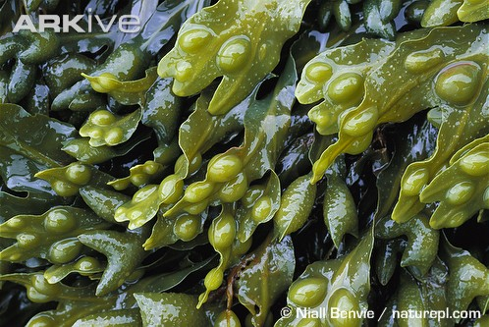

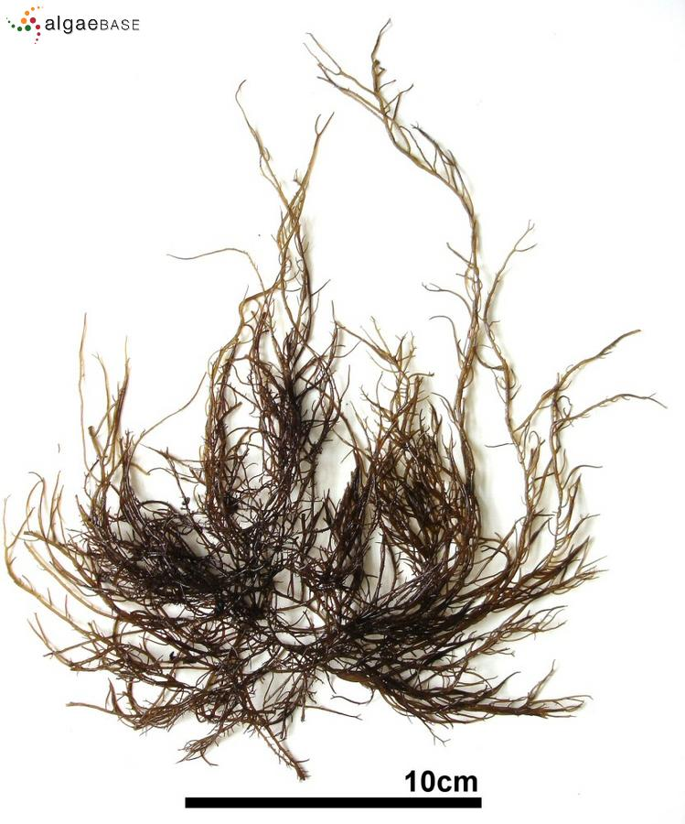
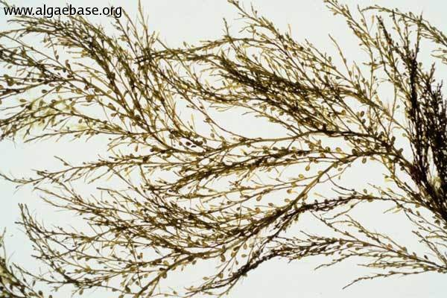
Bladder wrack (Fucus vesiculosus)
http://www.arkive.org/species/ARK/plants_and_algae/Fucus_vesiculosus/

Gracilaria vermiculophylla
http://www.algaebase.org/search/species/detail/?species_id=4417
Japanese seaweed (Sargassum muticum)
http://www.issg.org/database/species/ecology.asp?si=727&fr=1&sts=sss
The species are expected to increase in abundance over the next years. In France, the Japanese seaweed was recorded to replace local algal species. This has not been observed in the SE Wadden Sea yet. However, it cannot be excluded that this might happen in the Wadden Sea.
Measures to eradicate S. muticum at the Scottish coast have proven to be unsuccessful. Since there is insufficient knowledge it is not possible to predict the future effects on the Wadden Sea.
Therefore, more research is needed in this field of study.

